

MATHEMATICAL MODELING

KM185103

lecturer of q-class:

prof. dr. basuki widodo, m.sc

final exam

**Venansius ryan tjahjono 06111540000043**

MATHEMATICS DEPARTMENT

FACULTY OF MATHEMATICS, COMPUTING, AND DATA SCIENCE

INSTITUT TEKNOLOGI SEPULUH NOPEMBER

SURABAYA 2018

# ELECTRICAL POTENTIAL PROBLEM – SIMULATION WITH MATLAB

SOURCE CODE

function varargout = EPSimulation(varargin)

% EPSIMULATION MATLAB code for EPSimulation.fig

% EPSIMULATION, by itself, creates a new EPSIMULATION or raises the existing

% singleton*.

%

% H = EPSIMULATION returns the handle to a new EPSIMULATION or the handle to

% the existing singleton*.

%

% EPSIMULATION('CALLBACK',hObject,eventData,handles,...) calls the local

% function named CALLBACK in EPSIMULATION.M with the given input arguments.

%

% EPSIMULATION('Property','Value',...) creates a new EPSIMULATION or raises the

% existing singleton*. Starting from the left, property value pairs are

% applied to the GUI before EPSimulation_OpeningFcn gets called. An

% unrecognized property name or invalid value makes property application

% stop. All inputs are passed to EPSimulation_OpeningFcn via varargin.

%

% *See GUI Options on GUIDE's Tools menu. Choose "GUI allows only one

% instance to run (singleton)".

%

% See also: GUIDE, GUIDATA, GUIHANDLES

% Edit the above text to modify the response to help EPSimulation

% Last Modified by GUIDE v2.5 01-Dec-2018 17:11:21

% Begin initialization code - DO NOT EDIT

gui_Singleton = 1;

gui_State = struct('gui_Name', mfilename, ...

'gui_Singleton', gui_Singleton, ...

'gui_OpeningFcn', @EPSimulation_OpeningFcn, ...

'gui_OutputFcn', @EPSimulation_OutputFcn, ...

'gui_LayoutFcn', [] , ...

'gui_Callback', []);

if nargin && ischar(varargin{1})

gui_State.gui_Callback = str2func(varargin{1});

end

if nargout

[varargout{1:nargout}] = gui_mainfcn(gui_State, varargin{:});

else

gui_mainfcn(gui_State, varargin{:});

end

% End initialization code - DO NOT EDIT

% --- Executes just before EPSimulation is made visible.

function EPSimulation_OpeningFcn(hObject, eventdata, handles, varargin)

% This function has no output args, see OutputFcn.

% hObject handle to figure

% eventdata reserved - to be defined in a future version of MATLAB

% handles structure with handles and user data (see GUIDATA)

% varargin command line arguments to EPSimulation (see VARARGIN)

% Choose default command line output for EPSimulation

handles.output = hObject;

axes(handles.axes1)

imshow('picits1.png')

axes(handles.axes2)

imshow('picmath1.png')

axes(handles.axes3)

zlabel('VOLTAGE','FontSize',10,'FontWeight','bold','Color','w');

axes(handles.axes4)

zlabel('VOLTAGE','FontSize',10,'FontWeight','bold','Color','w');

% Update handles structure

guidata(hObject, handles);

% UIWAIT makes EPSimulation wait for user response (see UIRESUME)

% uiwait(handles.figure1);

% --- Outputs from this function are returned to the command line.

function varargout = EPSimulation_OutputFcn(hObject, eventdata, handles)

% varargout cell array for returning output args (see VARARGOUT);

% hObject handle to figure

% eventdata reserved - to be defined in a future version of MATLAB

% handles structure with handles and user data (see GUIDATA)

% Get default command line output from handles structure

varargout{1} = handles.output;

% --- Executes on button press in pushbutton1.

function pushbutton1_Callback(hObject, eventdata, handles)

% hObject handle to pushbutton1 (see GCBO)

% eventdata reserved - to be defined in a future version of MATLAB

% handles structure with handles and user data (see GUIDATA)

axes(handles.axes3); tic;

L = str2num(get(handles.edit11,'String'));

n = str2num(get(handles.edit12,'String'));

A = str2num(get(handles.edit13,'String'));

t = str2num(get(handles.edit14,'String'));

[X,Y] = meshgrid(0:0.1:t);

Z = @(x,y,A,L,n) A.*sin(n.*pi.*x./L).*sinh(n.*pi.*y./L)./10*sinh(n.*pi);

mesh(X,Y,Z(X,Y,A,L,n));

zlabel('VOLTAGE','FontSize',10,'FontWeight','bold','Color','k');

xlabel('X-axis','FontSize',10,'FontWeight','bold','Color','k');

ylabel('Y-axis','FontSize',10,'FontWeight','bold','Color','k');

rotate3d on;

axes(handles.axes4);

XX = strcat('n = ',' ',num2str(n));

plot(X(1,:),Z(X(1,:),1,A,L,n),'linewidth',2);

legend (XX);

grid on;

set(handles.edit15,'String',round(toc*10000)/10000);

% --- Executes on button press in pushbutton2.

function pushbutton2_Callback(hObject, eventdata, handles)

% hObject handle to pushbutton2 (see GCBO)

% eventdata reserved - to be defined in a future version of MATLAB

% handles structure with handles and user data (see GUIDATA)

set(handles.edit11, 'String', '');

set(handles.edit12, 'String', '');

set(handles.edit13, 'String', '');

set(handles.edit14, 'String', '');

set(handles.edit15, 'String', '');

cla(handles.axes3);

cla(handles.axes4);

legend('hide');

function edit11_Callback(hObject, eventdata, handles)

% hObject handle to edit11 (see GCBO)

% eventdata reserved - to be defined in a future version of MATLAB

% handles structure with handles and user data (see GUIDATA)

% Hints: get(hObject,'String') returns contents of edit11 as text

% str2double(get(hObject,'String')) returns contents of edit11 as a double

% --- Executes during object creation, after setting all properties.

function edit11_CreateFcn(hObject, eventdata, handles)

% hObject handle to edit11 (see GCBO)

% eventdata reserved - to be defined in a future version of MATLAB

% handles empty - handles not created until after all CreateFcns called

% Hint: edit controls usually have a white background on Windows.

% See ISPC and COMPUTER.

if ispc && isequal(get(hObject,'BackgroundColor'), get(0,'defaultUicontrolBackgroundColor'))

set(hObject,'BackgroundColor','white');

end

function edit12_Callback(hObject, eventdata, handles)

% hObject handle to edit12 (see GCBO)

% eventdata reserved - to be defined in a future version of MATLAB

% handles structure with handles and user data (see GUIDATA)

% Hints: get(hObject,'String') returns contents of edit12 as text

% str2double(get(hObject,'String')) returns contents of edit12 as a double

% --- Executes during object creation, after setting all properties.

function edit12_CreateFcn(hObject, eventdata, handles)

% hObject handle to edit12 (see GCBO)

% eventdata reserved - to be defined in a future version of MATLAB

% handles empty - handles not created until after all CreateFcns called

% Hint: edit controls usually have a white background on Windows.

% See ISPC and COMPUTER.

if ispc && isequal(get(hObject,'BackgroundColor'), get(0,'defaultUicontrolBackgroundColor'))

set(hObject,'BackgroundColor','white');

end

function edit13_Callback(hObject, eventdata, handles)

% hObject handle to edit13 (see GCBO)

% eventdata reserved - to be defined in a future version of MATLAB

% handles structure with handles and user data (see GUIDATA)

% Hints: get(hObject,'String') returns contents of edit13 as text

% str2double(get(hObject,'String')) returns contents of edit13 as a double

% --- Executes during object creation, after setting all properties.

function edit13_CreateFcn(hObject, eventdata, handles)

% hObject handle to edit13 (see GCBO)

% eventdata reserved - to be defined in a future version of MATLAB

% handles empty - handles not created until after all CreateFcns called

% Hint: edit controls usually have a white background on Windows.

% See ISPC and COMPUTER.

if ispc && isequal(get(hObject,'BackgroundColor'), get(0,'defaultUicontrolBackgroundColor'))

set(hObject,'BackgroundColor','white');

end

function edit14_Callback(hObject, eventdata, handles)

% hObject handle to edit14 (see GCBO)

% eventdata reserved - to be defined in a future version of MATLAB

% handles structure with handles and user data (see GUIDATA)

% Hints: get(hObject,'String') returns contents of edit14 as text

% str2double(get(hObject,'String')) returns contents of edit14 as a double

% --- Executes during object creation, after setting all properties.

function edit14_CreateFcn(hObject, eventdata, handles)

% hObject handle to edit14 (see GCBO)

% eventdata reserved - to be defined in a future version of MATLAB

% handles empty - handles not created until after all CreateFcns called

% Hint: edit controls usually have a white background on Windows.

% See ISPC and COMPUTER.

if ispc && isequal(get(hObject,'BackgroundColor'), get(0,'defaultUicontrolBackgroundColor'))

set(hObject,'BackgroundColor','white');

end

function edit15_Callback(hObject, eventdata, handles)

% hObject handle to edit15 (see GCBO)

% eventdata reserved - to be defined in a future version of MATLAB

% handles structure with handles and user data (see GUIDATA)

% Hints: get(hObject,'String') returns contents of edit15 as text

% str2double(get(hObject,'String')) returns contents of edit15 as a double

% --- Executes during object creation, after setting all properties.

function edit15_CreateFcn(hObject, eventdata, handles)

% hObject handle to edit15 (see GCBO)

% eventdata reserved - to be defined in a future version of MATLAB

% handles empty - handles not created until after all CreateFcns called

% Hint: edit controls usually have a white background on Windows.

% See ISPC and COMPUTER.

if ispc && isequal(get(hObject,'BackgroundColor'), get(0,'defaultUicontrolBackgroundColor'))

set(hObject,'BackgroundColor','white');

end

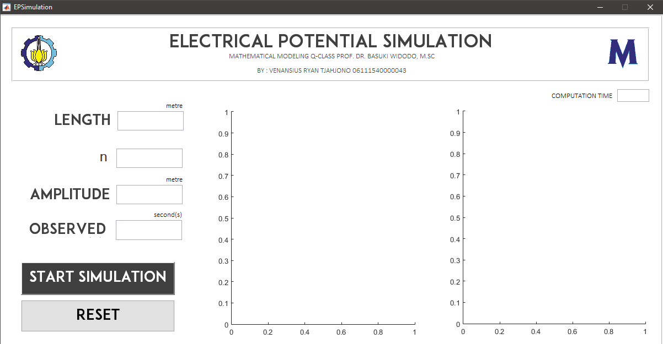

GRAPHICAL USER INTERFACE

Simulation result with various length, , and observed time 5 seconds

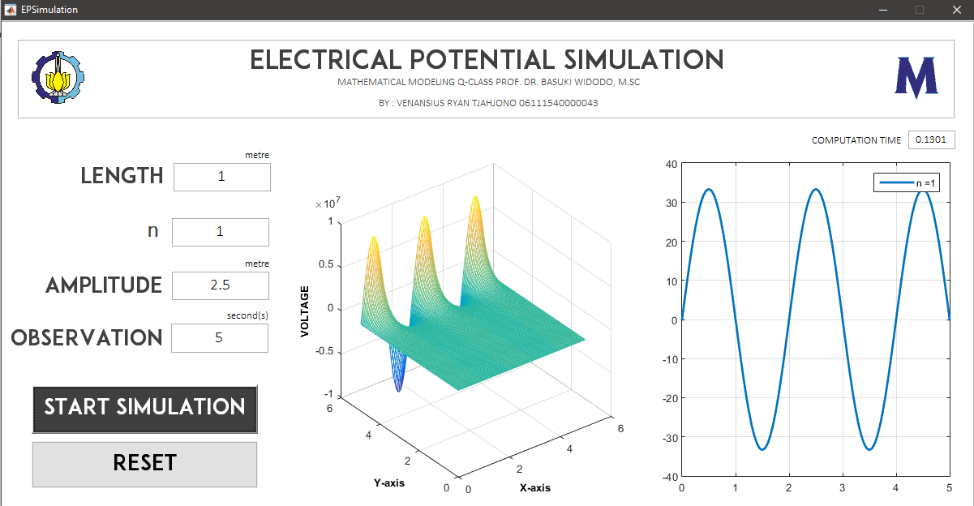

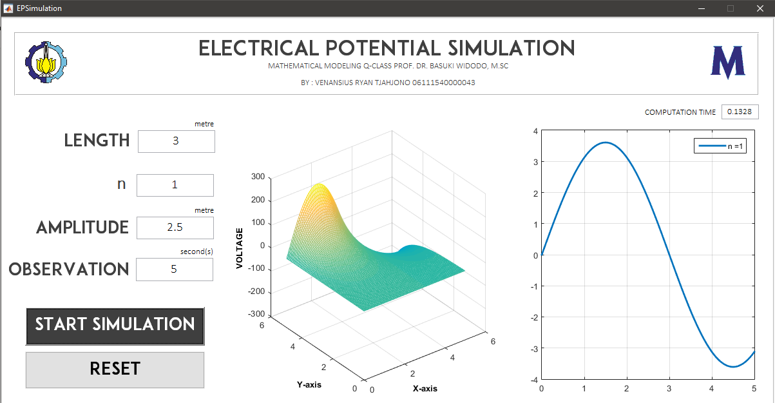

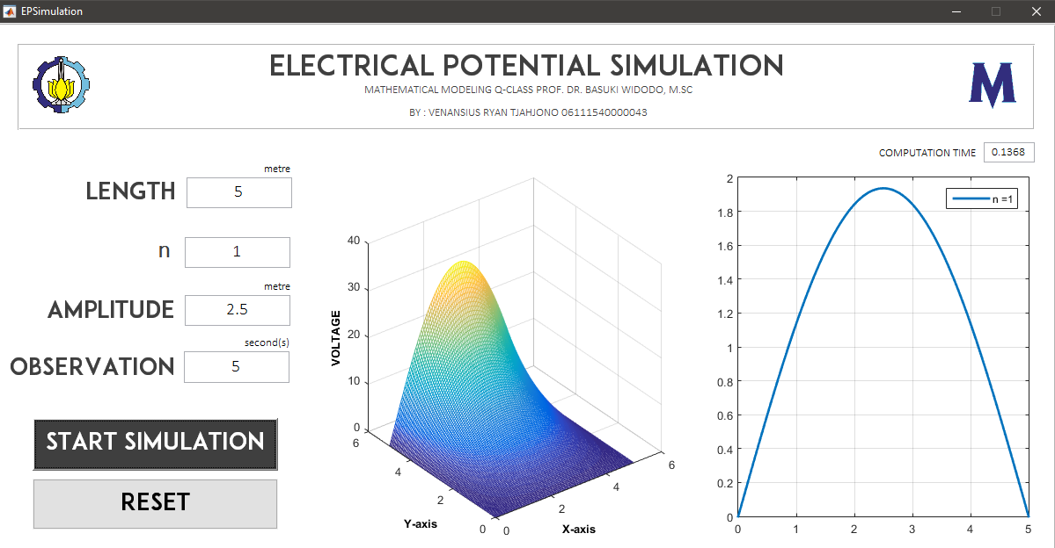

Simulation result with various amplitude, , and observed time 5 seconds

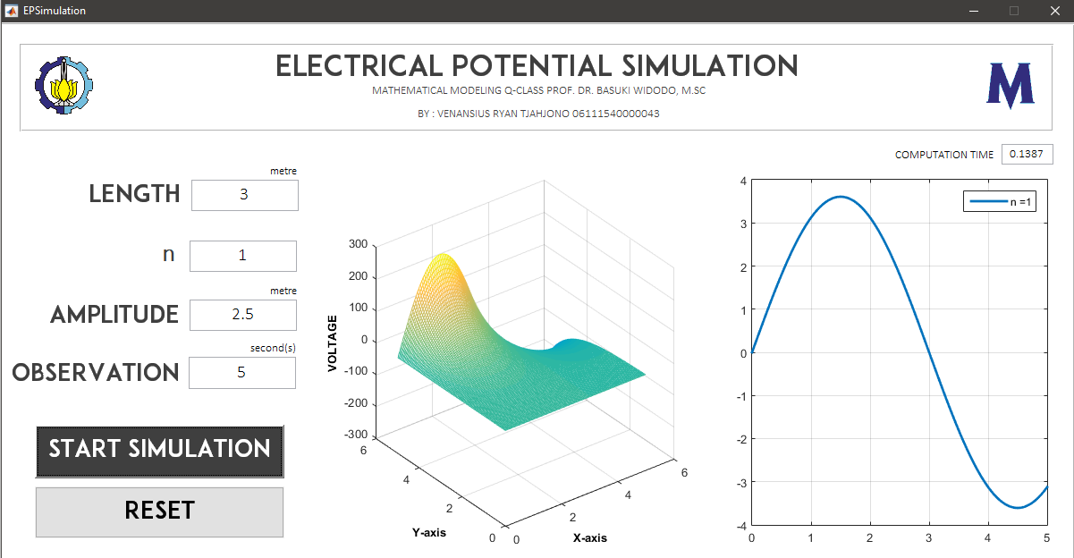

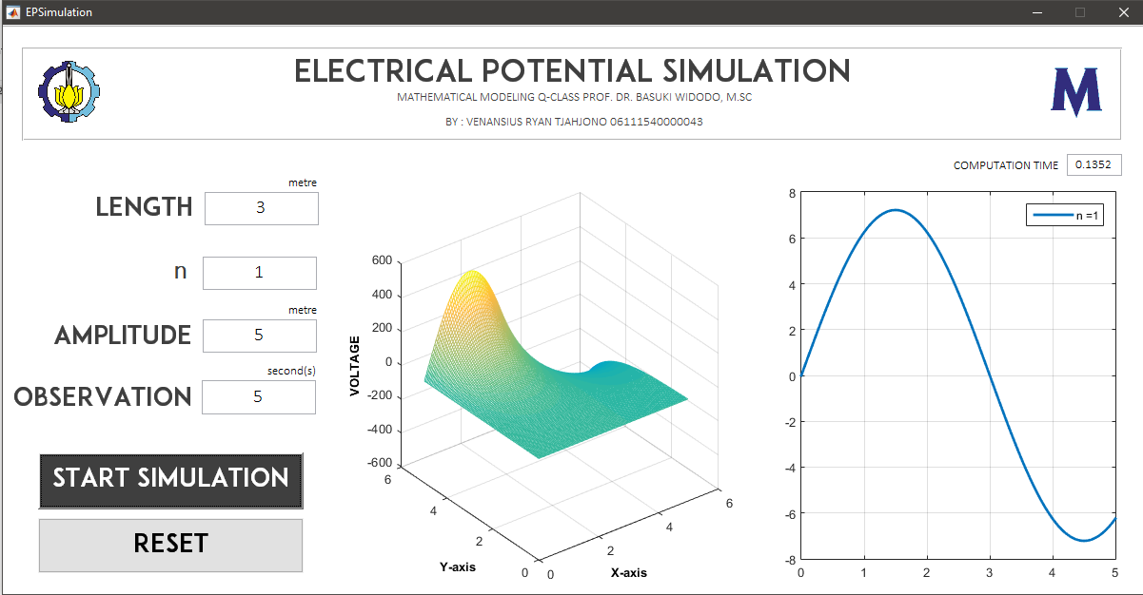

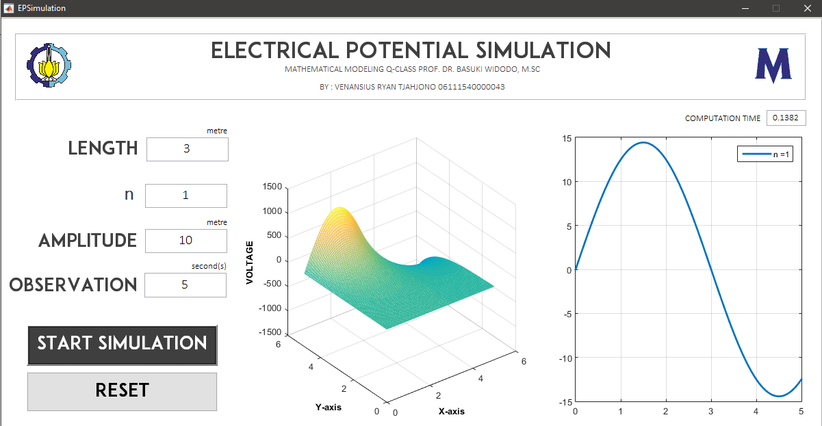

Simulation result with various observation time, , and

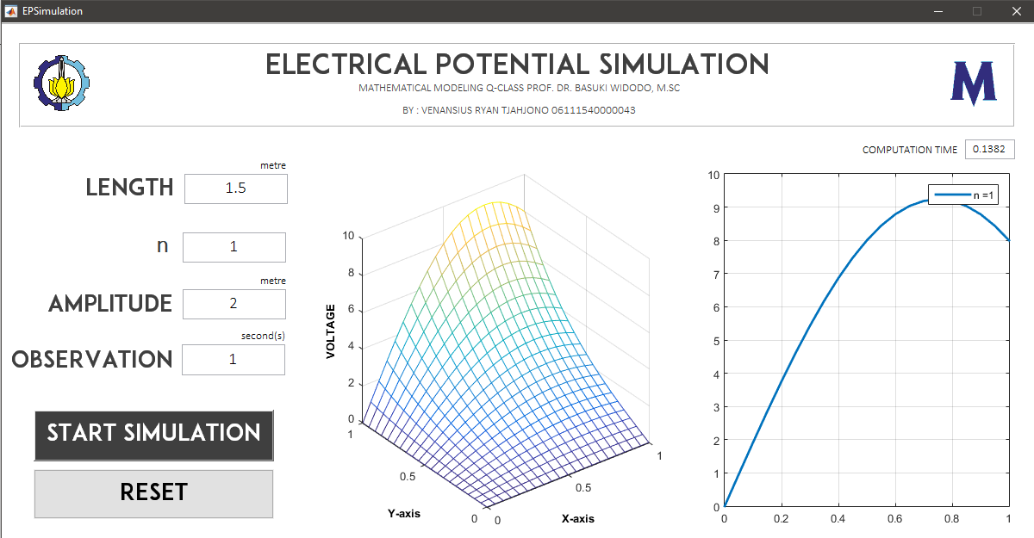

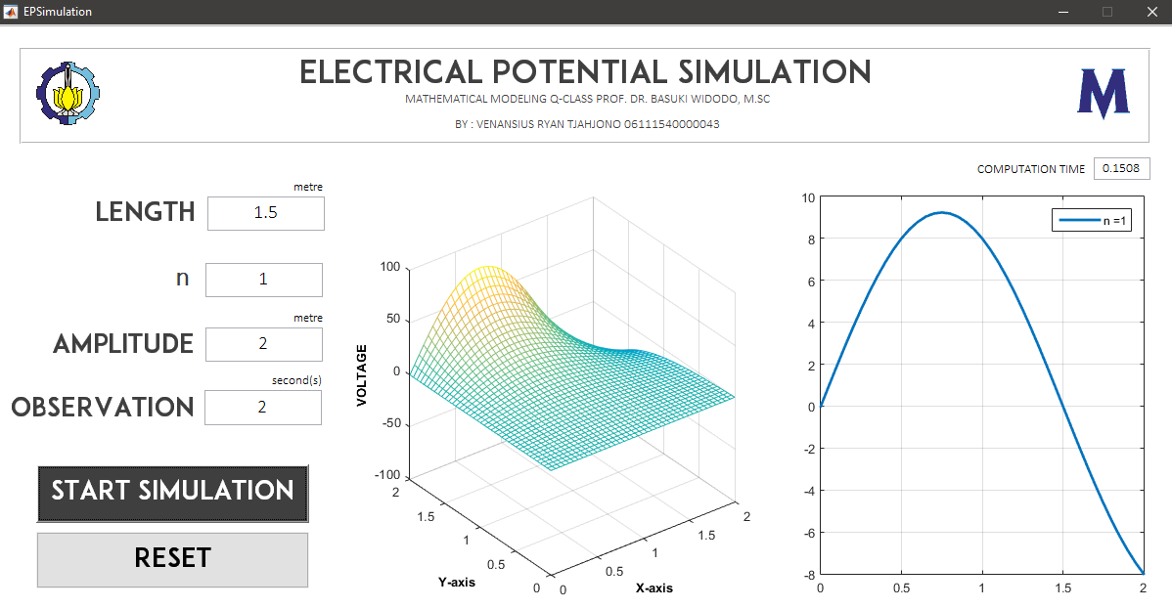

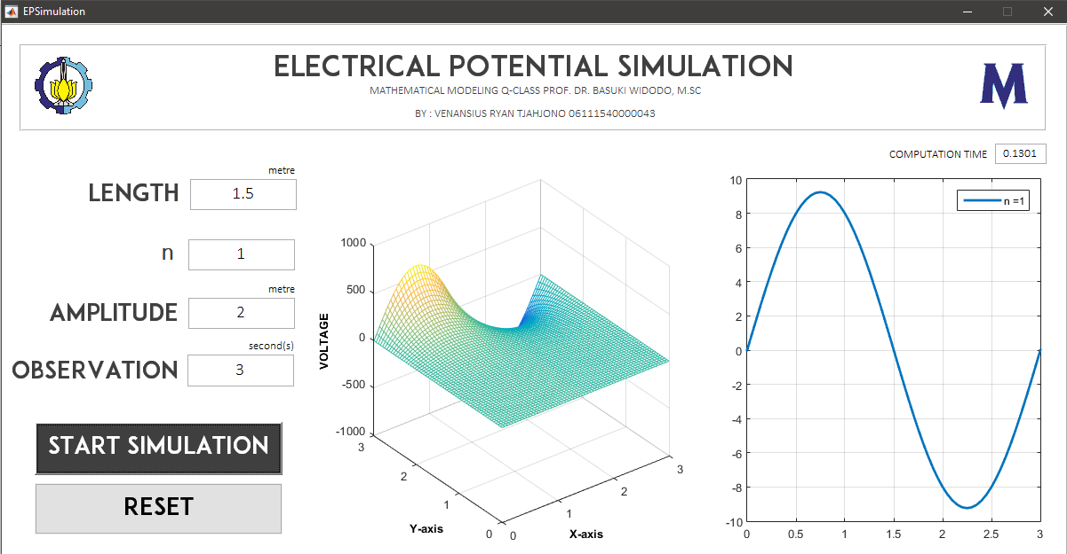

CONCLUSION

With main model of electrical potential problem,



With boundary & initial condition,

Afterwards, regarding to analytic solution, this simulation is made with results:

1. If getting larger, the frequency of the voltage is slower.
2. Mostly, amplitude value does not affect the frequency, but affect directly to the value of voltage produced.
3. Observation time can make the simulation more palpable. The picture in page 9 illustrates how the electrical potential moves along -grid coordinates.

# SPREADING DYNAMIC OF A CONTAGIOUS DISEASE IN HETEROGENIC POPULATION OF LIVING BEINGS WITH MULTI GROUP MODEL APPROACH – SIMULATION WITH MATLAB

SOURCE CODE

function varargout = SpreaDiseasesSim(varargin)

% SPREADISEASESSIM MATLAB code for SpreaDiseasesSim.fig

% SPREADISEASESSIM, by itself, creates a new SPREADISEASESSIM or raises the existing

% singleton*.

%

% H = SPREADISEASESSIM returns the handle to a new SPREADISEASESSIM or the handle to

% the existing singleton*.

%

% SPREADISEASESSIM('CALLBACK',hObject,eventData,handles,...) calls the local

% function named CALLBACK in SPREADISEASESSIM.M with the given input arguments.

%

% SPREADISEASESSIM('Property','Value',...) creates a new SPREADISEASESSIM or raises the

% existing singleton*. Starting from the left, property value pairs are

% applied to the GUI before SpreaDiseasesSim_OpeningFcn gets called. An

% unrecognized property name or invalid value makes property application

% stop. All inputs are passed to SpreaDiseasesSim_OpeningFcn via varargin.

%

% *See GUI Options on GUIDE's Tools menu. Choose "GUI allows only one

% instance to run (singleton)".

%

% See also: GUIDE, GUIDATA, GUIHANDLES

% Edit the above text to modify the response to help SpreaDiseasesSim

% Last Modified by GUIDE v2.5 05-Dec-2018 20:13:03

% Begin initialization code - DO NOT EDIT

gui_Singleton = 1;

gui_State = struct('gui_Name', mfilename, ...

'gui_Singleton', gui_Singleton, ...

'gui_OpeningFcn', @SpreaDiseasesSim_OpeningFcn, ...

'gui_OutputFcn', @SpreaDiseasesSim_OutputFcn, ...

'gui_LayoutFcn', [] , ...

'gui_Callback', []);

if nargin && ischar(varargin{1})

gui_State.gui_Callback = str2func(varargin{1});

end

if nargout

[varargout{1:nargout}] = gui_mainfcn(gui_State, varargin{:});

else

gui_mainfcn(gui_State, varargin{:});

end

% End initialization code - DO NOT EDIT

% --- Executes just before SpreaDiseasesSim is made visible.

function SpreaDiseasesSim_OpeningFcn(hObject, eventdata, handles, varargin)

% This function has no output args, see OutputFcn.

% hObject handle to figure

% eventdata reserved - to be defined in a future version of MATLAB

% handles structure with handles and user data (see GUIDATA)

% varargin command line arguments to SpreaDiseasesSim (see VARARGIN)

% Choose default command line output for SpreaDiseasesSim

handles.output = hObject;

axes(handles.axes1); imshow('picitsx.png');

axes(handles.axes2); imshow('picmathx.png');

axes(handles.axes3); grid on;

xlabel ('TIME','FontSize',12,'FontWeight','bold');

ylabel ('POPULATION','FontSize',12,'FontWeight','bold');

% Update handles structure

guidata(hObject, handles);

% UIWAIT makes SpreaDiseasesSim wait for user response (see UIRESUME)

% uiwait(handles.figure1);

% --- Outputs from this function are returned to the command line.

function varargout = SpreaDiseasesSim_OutputFcn(hObject, eventdata, handles)

% varargout cell array for returning output args (see VARARGOUT);

% hObject handle to figure

% eventdata reserved - to be defined in a future version of MATLAB

% handles structure with handles and user data (see GUIDATA)

% Get default command line output from handles structure

varargout{1} = handles.output;

function edit1_Callback(hObject, eventdata, handles)

% hObject handle to edit1 (see GCBO)

% eventdata reserved - to be defined in a future version of MATLAB

% handles structure with handles and user data (see GUIDATA)

% Hints: get(hObject,'String') returns contents of edit1 as text

% str2double(get(hObject,'String')) returns contents of edit1 as a double

% --- Executes during object creation, after setting all properties.

function edit1_CreateFcn(hObject, eventdata, handles)

% hObject handle to edit1 (see GCBO)

% eventdata reserved - to be defined in a future version of MATLAB

% handles empty - handles not created until after all CreateFcns called

% Hint: edit controls usually have a white background on Windows.

% See ISPC and COMPUTER.

if ispc && isequal(get(hObject,'BackgroundColor'), get(0,'defaultUicontrolBackgroundColor'))

set(hObject,'BackgroundColor','white');

end

function edit2_Callback(hObject, eventdata, handles)

% hObject handle to edit2 (see GCBO)

% eventdata reserved - to be defined in a future version of MATLAB

% handles structure with handles and user data (see GUIDATA)

% Hints: get(hObject,'String') returns contents of edit2 as text

% str2double(get(hObject,'String')) returns contents of edit2 as a double

% --- Executes during object creation, after setting all properties.

function edit2_CreateFcn(hObject, eventdata, handles)

% hObject handle to edit2 (see GCBO)

% eventdata reserved - to be defined in a future version of MATLAB

% handles empty - handles not created until after all CreateFcns called

% Hint: edit controls usually have a white background on Windows.

% See ISPC and COMPUTER.

if ispc && isequal(get(hObject,'BackgroundColor'), get(0,'defaultUicontrolBackgroundColor'))

set(hObject,'BackgroundColor','white');

end

function edit3_Callback(hObject, eventdata, handles)

% hObject handle to edit3 (see GCBO)

% eventdata reserved - to be defined in a future version of MATLAB

% handles structure with handles and user data (see GUIDATA)

% Hints: get(hObject,'String') returns contents of edit3 as text

% str2double(get(hObject,'String')) returns contents of edit3 as a double

% --- Executes during object creation, after setting all properties.

function edit3_CreateFcn(hObject, eventdata, handles)

% hObject handle to edit3 (see GCBO)

% eventdata reserved - to be defined in a future version of MATLAB

% handles empty - handles not created until after all CreateFcns called

% Hint: edit controls usually have a white background on Windows.

% See ISPC and COMPUTER.

if ispc && isequal(get(hObject,'BackgroundColor'), get(0,'defaultUicontrolBackgroundColor'))

set(hObject,'BackgroundColor','white');

end

function edit4_Callback(hObject, eventdata, handles)

% hObject handle to edit4 (see GCBO)

% eventdata reserved - to be defined in a future version of MATLAB

% handles structure with handles and user data (see GUIDATA)

% Hints: get(hObject,'String') returns contents of edit4 as text

% str2double(get(hObject,'String')) returns contents of edit4 as a double

% --- Executes during object creation, after setting all properties.

function edit4_CreateFcn(hObject, eventdata, handles)

% hObject handle to edit4 (see GCBO)

% eventdata reserved - to be defined in a future version of MATLAB

% handles empty - handles not created until after all CreateFcns called

% Hint: edit controls usually have a white background on Windows.

% See ISPC and COMPUTER.

if ispc && isequal(get(hObject,'BackgroundColor'), get(0,'defaultUicontrolBackgroundColor'))

set(hObject,'BackgroundColor','white');

end

function edit5_Callback(hObject, eventdata, handles)

% hObject handle to edit5 (see GCBO)

% eventdata reserved - to be defined in a future version of MATLAB

% handles structure with handles and user data (see GUIDATA)

% Hints: get(hObject,'String') returns contents of edit5 as text

% str2double(get(hObject,'String')) returns contents of edit5 as a double

% --- Executes during object creation, after setting all properties.

function edit5_CreateFcn(hObject, eventdata, handles)

% hObject handle to edit5 (see GCBO)

% eventdata reserved - to be defined in a future version of MATLAB

% handles empty - handles not created until after all CreateFcns called

% Hint: edit controls usually have a white background on Windows.

% See ISPC and COMPUTER.

if ispc && isequal(get(hObject,'BackgroundColor'), get(0,'defaultUicontrolBackgroundColor'))

set(hObject,'BackgroundColor','white');

end

function edit6_Callback(hObject, eventdata, handles)

% hObject handle to edit6 (see GCBO)

% eventdata reserved - to be defined in a future version of MATLAB

% handles structure with handles and user data (see GUIDATA)

% Hints: get(hObject,'String') returns contents of edit6 as text

% str2double(get(hObject,'String')) returns contents of edit6 as a double

% --- Executes during object creation, after setting all properties.

function edit6_CreateFcn(hObject, eventdata, handles)

% hObject handle to edit6 (see GCBO)

% eventdata reserved - to be defined in a future version of MATLAB

% handles empty - handles not created until after all CreateFcns called

% Hint: edit controls usually have a white background on Windows.

% See ISPC and COMPUTER.

if ispc && isequal(get(hObject,'BackgroundColor'), get(0,'defaultUicontrolBackgroundColor'))

set(hObject,'BackgroundColor','white');

end

function edit7_Callback(hObject, eventdata, handles)

% hObject handle to edit7 (see GCBO)

% eventdata reserved - to be defined in a future version of MATLAB

% handles structure with handles and user data (see GUIDATA)

% Hints: get(hObject,'String') returns contents of edit7 as text

% str2double(get(hObject,'String')) returns contents of edit7 as a double

% --- Executes during object creation, after setting all properties.

function edit7_CreateFcn(hObject, eventdata, handles)

% hObject handle to edit7 (see GCBO)

% eventdata reserved - to be defined in a future version of MATLAB

% handles empty - handles not created until after all CreateFcns called

% Hint: edit controls usually have a white background on Windows.

% See ISPC and COMPUTER.

if ispc && isequal(get(hObject,'BackgroundColor'), get(0,'defaultUicontrolBackgroundColor'))

set(hObject,'BackgroundColor','white');

end

function edit8_Callback(hObject, eventdata, handles)

% hObject handle to edit8 (see GCBO)

% eventdata reserved - to be defined in a future version of MATLAB

% handles structure with handles and user data (see GUIDATA)

% Hints: get(hObject,'String') returns contents of edit8 as text

% str2double(get(hObject,'String')) returns contents of edit8 as a double

% --- Executes during object creation, after setting all properties.

function edit8_CreateFcn(hObject, eventdata, handles)

% hObject handle to edit8 (see GCBO)

% eventdata reserved - to be defined in a future version of MATLAB

% handles empty - handles not created until after all CreateFcns called

% Hint: edit controls usually have a white background on Windows.

% See ISPC and COMPUTER.

if ispc && isequal(get(hObject,'BackgroundColor'), get(0,'defaultUicontrolBackgroundColor'))

set(hObject,'BackgroundColor','white');

end

function edit9_Callback(hObject, eventdata, handles)

% hObject handle to edit9 (see GCBO)

% eventdata reserved - to be defined in a future version of MATLAB

% handles structure with handles and user data (see GUIDATA)

% Hints: get(hObject,'String') returns contents of edit9 as text

% str2double(get(hObject,'String')) returns contents of edit9 as a double

% --- Executes during object creation, after setting all properties.

function edit9_CreateFcn(hObject, eventdata, handles)

% hObject handle to edit9 (see GCBO)

% eventdata reserved - to be defined in a future version of MATLAB

% handles empty - handles not created until after all CreateFcns called

% Hint: edit controls usually have a white background on Windows.

% See ISPC and COMPUTER.

if ispc && isequal(get(hObject,'BackgroundColor'), get(0,'defaultUicontrolBackgroundColor'))

set(hObject,'BackgroundColor','white');

end

function edit10_Callback(hObject, eventdata, handles)

% hObject handle to edit10 (see GCBO)

% eventdata reserved - to be defined in a future version of MATLAB

% handles structure with handles and user data (see GUIDATA)

% Hints: get(hObject,'String') returns contents of edit10 as text

% str2double(get(hObject,'String')) returns contents of edit10 as a double

% --- Executes during object creation, after setting all properties.

function edit10_CreateFcn(hObject, eventdata, handles)

% hObject handle to edit10 (see GCBO)

% eventdata reserved - to be defined in a future version of MATLAB

% handles empty - handles not created until after all CreateFcns called

% Hint: edit controls usually have a white background on Windows.

% See ISPC and COMPUTER.

if ispc && isequal(get(hObject,'BackgroundColor'), get(0,'defaultUicontrolBackgroundColor'))

set(hObject,'BackgroundColor','white');

end

function edit11_Callback(hObject, eventdata, handles)

% hObject handle to edit11 (see GCBO)

% eventdata reserved - to be defined in a future version of MATLAB

% handles structure with handles and user data (see GUIDATA)

% Hints: get(hObject,'String') returns contents of edit11 as text

% str2double(get(hObject,'String')) returns contents of edit11 as a double

% --- Executes during object creation, after setting all properties.

function edit11_CreateFcn(hObject, eventdata, handles)

% hObject handle to edit11 (see GCBO)

% eventdata reserved - to be defined in a future version of MATLAB

% handles empty - handles not created until after all CreateFcns called

% Hint: edit controls usually have a white background on Windows.

% See ISPC and COMPUTER.

if ispc && isequal(get(hObject,'BackgroundColor'), get(0,'defaultUicontrolBackgroundColor'))

set(hObject,'BackgroundColor','white');

end

function edit12_Callback(hObject, eventdata, handles)

% hObject handle to edit12 (see GCBO)

% eventdata reserved - to be defined in a future version of MATLAB

% handles structure with handles and user data (see GUIDATA)

% Hints: get(hObject,'String') returns contents of edit12 as text

% str2double(get(hObject,'String')) returns contents of edit12 as a double

% --- Executes during object creation, after setting all properties.

function edit12_CreateFcn(hObject, eventdata, handles)

% hObject handle to edit12 (see GCBO)

% eventdata reserved - to be defined in a future version of MATLAB

% handles empty - handles not created until after all CreateFcns called

% Hint: edit controls usually have a white background on Windows.

% See ISPC and COMPUTER.

if ispc && isequal(get(hObject,'BackgroundColor'), get(0,'defaultUicontrolBackgroundColor'))

set(hObject,'BackgroundColor','white');

end

function edit13_Callback(hObject, eventdata, handles)

% hObject handle to edit13 (see GCBO)

% eventdata reserved - to be defined in a future version of MATLAB

% handles structure with handles and user data (see GUIDATA)

% Hints: get(hObject,'String') returns contents of edit13 as text

% str2double(get(hObject,'String')) returns contents of edit13 as a double

% --- Executes during object creation, after setting all properties.

function edit13_CreateFcn(hObject, eventdata, handles)

% hObject handle to edit13 (see GCBO)

% eventdata reserved - to be defined in a future version of MATLAB

% handles empty - handles not created until after all CreateFcns called

% Hint: edit controls usually have a white background on Windows.

% See ISPC and COMPUTER.

if ispc && isequal(get(hObject,'BackgroundColor'), get(0,'defaultUicontrolBackgroundColor'))

set(hObject,'BackgroundColor','white');

end

function edit14_Callback(hObject, eventdata, handles)

% hObject handle to edit14 (see GCBO)

% eventdata reserved - to be defined in a future version of MATLAB

% handles structure with handles and user data (see GUIDATA)

% Hints: get(hObject,'String') returns contents of edit14 as text

% str2double(get(hObject,'String')) returns contents of edit14 as a double

% --- Executes during object creation, after setting all properties.

function edit14_CreateFcn(hObject, eventdata, handles)

% hObject handle to edit14 (see GCBO)

% eventdata reserved - to be defined in a future version of MATLAB

% handles empty - handles not created until after all CreateFcns called

% Hint: edit controls usually have a white background on Windows.

% See ISPC and COMPUTER.

if ispc && isequal(get(hObject,'BackgroundColor'), get(0,'defaultUicontrolBackgroundColor'))

set(hObject,'BackgroundColor','white');

end

function edit15_Callback(hObject, eventdata, handles)

% hObject handle to edit15 (see GCBO)

% eventdata reserved - to be defined in a future version of MATLAB

% handles structure with handles and user data (see GUIDATA)

% Hints: get(hObject,'String') returns contents of edit15 as text

% str2double(get(hObject,'String')) returns contents of edit15 as a double

% --- Executes during object creation, after setting all properties.

function edit15_CreateFcn(hObject, ~, handles)

% hObject handle to edit15 (see GCBO)

% eventdata reserved - to be defined in a future version of MATLAB

% handles empty - handles not created until after all CreateFcns called

% Hint: edit controls usually have a white background on Windows.

% See ISPC and COMPUTER.

if ispc && isequal(get(hObject,'BackgroundColor'), get(0,'defaultUicontrolBackgroundColor'))

set(hObject,'BackgroundColor','white');

end

function edit16_Callback(hObject, eventdata, handles)

% hObject handle to edit16 (see GCBO)

% eventdata reserved - to be defined in a future version of MATLAB

% handles structure with handles and user data (see GUIDATA)

% Hints: get(hObject,'String') returns contents of edit16 as text

% str2double(get(hObject,'String')) returns contents of edit16 as a double

% --- Executes during object creation, after setting all properties.

function edit16_CreateFcn(hObject, eventdata, handles)

% hObject handle to edit16 (see GCBO)

% eventdata reserved - to be defined in a future version of MATLAB

% handles empty - handles not created until after all CreateFcns called

% Hint: edit controls usually have a white background on Windows.

% See ISPC and COMPUTER.

if ispc && isequal(get(hObject,'BackgroundColor'), get(0,'defaultUicontrolBackgroundColor'))

set(hObject,'BackgroundColor','white');

end

function edit17_Callback(hObject, eventdata, handles)

% hObject handle to edit17 (see GCBO)

% eventdata reserved - to be defined in a future version of MATLAB

% handles structure with handles and user data (see GUIDATA)

% Hints: get(hObject,'String') returns contents of edit17 as text

% str2double(get(hObject,'String')) returns contents of edit17 as a double

% --- Executes during object creation, after setting all properties.

function edit17_CreateFcn(hObject, eventdata, handles)

% hObject handle to edit17 (see GCBO)

% eventdata reserved - to be defined in a future version of MATLAB

% handles empty - handles not created until after all CreateFcns called

% Hint: edit controls usually have a white background on Windows.

% See ISPC and COMPUTER.

if ispc && isequal(get(hObject,'BackgroundColor'), get(0,'defaultUicontrolBackgroundColor'))

set(hObject,'BackgroundColor','white');

end

function edit18_Callback(hObject, eventdata, handles)

% hObject handle to edit18 (see GCBO)

% eventdata reserved - to be defined in a future version of MATLAB

% handles structure with handles and user data (see GUIDATA)

% Hints: get(hObject,'String') returns contents of edit18 as text

% str2double(get(hObject,'String')) returns contents of edit18 as a double

% --- Executes during object creation, after setting all properties.

function edit18_CreateFcn(hObject, eventdata, handles)

% hObject handle to edit18 (see GCBO)

% eventdata reserved - to be defined in a future version of MATLAB

% handles empty - handles not created until after all CreateFcns called

% Hint: edit controls usually have a white background on Windows.

% See ISPC and COMPUTER.

if ispc && isequal(get(hObject,'BackgroundColor'), get(0,'defaultUicontrolBackgroundColor'))

set(hObject,'BackgroundColor','white');

end

function edit19_Callback(hObject, eventdata, handles)

% hObject handle to edit19 (see GCBO)

% eventdata reserved - to be defined in a future version of MATLAB

% handles structure with handles and user data (see GUIDATA)

% Hints: get(hObject,'String') returns contents of edit19 as text

% str2double(get(hObject,'String')) returns contents of edit19 as a double

% --- Executes during object creation, after setting all properties.

function edit19_CreateFcn(hObject, eventdata, handles)

% hObject handle to edit19 (see GCBO)

% eventdata reserved - to be defined in a future version of MATLAB

% handles empty - handles not created until after all CreateFcns called

% Hint: edit controls usually have a white background on Windows.

% See ISPC and COMPUTER.

if ispc && isequal(get(hObject,'BackgroundColor'), get(0,'defaultUicontrolBackgroundColor'))

set(hObject,'BackgroundColor','white');

end

function edit20_Callback(hObject, eventdata, handles)

% hObject handle to edit20 (see GCBO)

% eventdata reserved - to be defined in a future version of MATLAB

% handles structure with handles and user data (see GUIDATA)

% Hints: get(hObject,'String') returns contents of edit20 as text

% str2double(get(hObject,'String')) returns contents of edit20 as a double

% --- Executes during object creation, after setting all properties.

function edit20_CreateFcn(hObject, eventdata, handles)

% hObject handle to edit20 (see GCBO)

% eventdata reserved - to be defined in a future version of MATLAB

% handles empty - handles not created until after all CreateFcns called

% Hint: edit controls usually have a white background on Windows.

% See ISPC and COMPUTER.

if ispc && isequal(get(hObject,'BackgroundColor'), get(0,'defaultUicontrolBackgroundColor'))

set(hObject,'BackgroundColor','white');

end

function edit21_Callback(hObject, eventdata, handles)

% hObject handle to edit21 (see GCBO)

% eventdata reserved - to be defined in a future version of MATLAB

% handles structure with handles and user data (see GUIDATA)

% Hints: get(hObject,'String') returns contents of edit21 as text

% str2double(get(hObject,'String')) returns contents of edit21 as a double

% --- Executes during object creation, after setting all properties.

function edit21_CreateFcn(hObject, eventdata, handles)

% hObject handle to edit21 (see GCBO)

% eventdata reserved - to be defined in a future version of MATLAB

% handles empty - handles not created until after all CreateFcns called

% Hint: edit controls usually have a white background on Windows.

% See ISPC and COMPUTER.

if ispc && isequal(get(hObject,'BackgroundColor'), get(0,'defaultUicontrolBackgroundColor'))

set(hObject,'BackgroundColor','white');

end

function edit22_Callback(hObject, eventdata, handles)

% hObject handle to edit22 (see GCBO)

% eventdata reserved - to be defined in a future version of MATLAB

% handles structure with handles and user data (see GUIDATA)

% Hints: get(hObject,'String') returns contents of edit22 as text

% str2double(get(hObject,'String')) returns contents of edit22 as a double

% --- Executes during object creation, after setting all properties.

function edit22_CreateFcn(hObject, eventdata, handles)

% hObject handle to edit22 (see GCBO)

% eventdata reserved - to be defined in a future version of MATLAB

% handles empty - handles not created until after all CreateFcns called

% Hint: edit controls usually have a white background on Windows.

% See ISPC and COMPUTER.

if ispc && isequal(get(hObject,'BackgroundColor'), get(0,'defaultUicontrolBackgroundColor'))

set(hObject,'BackgroundColor','white');

end

function edit23_Callback(hObject, eventdata, handles)

% hObject handle to edit23 (see GCBO)

% eventdata reserved - to be defined in a future version of MATLAB

% handles structure with handles and user data (see GUIDATA)

% Hints: get(hObject,'String') returns contents of edit23 as text

% str2double(get(hObject,'String')) returns contents of edit23 as a double

% --- Executes during object creation, after setting all properties.

function edit23_CreateFcn(hObject, eventdata, handles)

% hObject handle to edit23 (see GCBO)

% eventdata reserved - to be defined in a future version of MATLAB

% handles empty - handles not created until after all CreateFcns called

% Hint: edit controls usually have a white background on Windows.

% See ISPC and COMPUTER.

if ispc && isequal(get(hObject,'BackgroundColor'), get(0,'defaultUicontrolBackgroundColor'))

set(hObject,'BackgroundColor','white');

end

function edit24_Callback(hObject, eventdata, handles)

% hObject handle to edit24 (see GCBO)

% eventdata reserved - to be defined in a future version of MATLAB

% handles structure with handles and user data (see GUIDATA)

% Hints: get(hObject,'String') returns contents of edit24 as text

% str2double(get(hObject,'String')) returns contents of edit24 as a double

% --- Executes during object creation, after setting all properties.

function edit24_CreateFcn(hObject, eventdata, handles)

% hObject handle to edit24 (see GCBO)

% eventdata reserved - to be defined in a future version of MATLAB

% handles empty - handles not created until after all CreateFcns called

% Hint: edit controls usually have a white background on Windows.

% See ISPC and COMPUTER.

if ispc && isequal(get(hObject,'BackgroundColor'), get(0,'defaultUicontrolBackgroundColor'))

set(hObject,'BackgroundColor','white');

end

function edit25_Callback(hObject, eventdata, handles)

% hObject handle to edit25 (see GCBO)

% eventdata reserved - to be defined in a future version of MATLAB

% handles structure with handles and user data (see GUIDATA)

% Hints: get(hObject,'String') returns contents of edit25 as text

% str2double(get(hObject,'String')) returns contents of edit25 as a double

% --- Executes during object creation, after setting all properties.

function edit25_CreateFcn(hObject, eventdata, handles)

% hObject handle to edit25 (see GCBO)

% eventdata reserved - to be defined in a future version of MATLAB

% handles empty - handles not created until after all CreateFcns called

% Hint: edit controls usually have a white background on Windows.

% See ISPC and COMPUTER.

if ispc && isequal(get(hObject,'BackgroundColor'), get(0,'defaultUicontrolBackgroundColor'))

set(hObject,'BackgroundColor','white');

end

function edit26_Callback(hObject, eventdata, handles)

% hObject handle to edit26 (see GCBO)

% eventdata reserved - to be defined in a future version of MATLAB

% handles structure with handles and user data (see GUIDATA)

% Hints: get(hObject,'String') returns contents of edit26 as text

% str2double(get(hObject,'String')) returns contents of edit26 as a double

% --- Executes during object creation, after setting all properties.

function edit26_CreateFcn(hObject, eventdata, handles)

% hObject handle to edit26 (see GCBO)

% eventdata reserved - to be defined in a future version of MATLAB

% handles empty - handles not created until after all CreateFcns called

% Hint: edit controls usually have a white background on Windows.

% See ISPC and COMPUTER.

if ispc && isequal(get(hObject,'BackgroundColor'), get(0,'defaultUicontrolBackgroundColor'))

set(hObject,'BackgroundColor','white');

end

% --- Executes on button press in pushbutton1.

function pushbutton1_Callback(hObject, eventdata, handles)

% hObject handle to pushbutton1 (see GCBO)

% eventdata reserved - to be defined in a future version of MATLAB

% handles structure with handles and user data (see GUIDATA)

%% Input

A1 = str2num(get(handles.edit1,'String'));

d1S = str2num(get(handles.edit2,'String'));

d1E = str2num(get(handles.edit3,'String'));

d1I = str2num(get(handles.edit4,'String'));

eps1 = str2num(get(handles.edit5,'String'));

gam1 = str2num(get(handles.edit6,'String'));

A2 = str2num(get(handles.edit7,'String'));

d2S = str2num(get(handles.edit8,'String'));

d2E = str2num(get(handles.edit9,'String'));

d2I = str2num(get(handles.edit10,'String'));

eps2 = str2num(get(handles.edit11,'String'));

gam2 = str2num(get(handles.edit12,'String'));

S1 = str2num(get(handles.edit13,'String'));

E1 = str2num(get(handles.edit14,'String'));

I1 = str2num(get(handles.edit15,'String'));

S2 = str2num(get(handles.edit16,'String'));

E2 = str2num(get(handles.edit17,'String'));

I2 = str2num(get(handles.edit18,'String'));

beta11 = str2num(get(handles.edit19,'String'));

beta12 = str2num(get(handles.edit20,'String'));

beta21 = str2num(get(handles.edit21,'String'));

beta22 = str2num(get(handles.edit22,'String'));

p1 = str2num(get(handles.edit23,'String'));

q1 = str2num(get(handles.edit24,'String'));

p2 = str2num(get(handles.edit25,'String'));

q2 = str2num(get(handles.edit26,'String'));

%% Check Basic Reprodudction Number

A = (beta11*eps1*p1*(I1^(p1-1))*S1^q1)/((d1E+eps1)*(d1I+gam1));

B = (beta22*eps2*p2*(I2^(p2-1))*S2^q2)/((d2E+eps2)*(d2I+gam2));

C = (beta11*eps1*p1*(I1^(p1-1))*S1^q1)*(beta22*eps2*p2*(I2^(p2-1))*S2^q2)/((d1E+eps1)*(d1I+gam1)*(d2E+eps2)*(d2I+gam2));

R0 = 0.5*((A+B)+sqrt((A-B)^2+4*C));

%% Plot

[T,Y] = ode45(@(t,y) spread_dis(t,y,A1,A2,d1S,d2S,d1E,d2E,d1I,d2I,eps1,eps2,gam1,gam2,beta11,beta12,beta21,beta22,p1,p2,q1,q2),[0 500],[S1 E1 I1 S2 E2 I2]);

plot(T,Y(:,1),T,Y(:,2),T,Y(:,3),T,Y(:,4),T,Y(:,5),T,Y(:,6),'linewidth',1.2);

legend('S1','E1','I1','S2','E2','I2');

grid on;

xlabel ('TIME','FontSize',12,'FontWeight','bold');

ylabel ('POPULATION','FontSize',12,'FontWeight','bold');

zoom on;

set(handles.edit27,'String',num2str(R0));

% --- Executes on button press in pushbutton2.

function pushbutton2_Callback(hObject, eventdata, handles)

% hObject handle to pushbutton2 (see GCBO)

% eventdata reserved - to be defined in a future version of MATLAB

% handles structure with handles and user data (see GUIDATA)

set(handles.edit1,'String',''); set(handles.edit2,'String','');

set(handles.edit3,'String',''); set(handles.edit4,'String','');

set(handles.edit5,'String',''); set(handles.edit6,'String','');

set(handles.edit7,'String',''); set(handles.edit8,'String','');

set(handles.edit9,'String',''); set(handles.edit10,'String','');

set(handles.edit11,'String',''); set(handles.edit12,'String','');

set(handles.edit13,'String',''); set(handles.edit14,'String','');

set(handles.edit15,'String',''); set(handles.edit16,'String','');

set(handles.edit17,'String',''); set(handles.edit18,'String','');

set(handles.edit19,'String',''); set(handles.edit20,'String','');

set(handles.edit21,'String',''); set(handles.edit22,'String','');

set(handles.edit23,'String',''); set(handles.edit24,'String','');

set(handles.edit25,'String',''); set(handles.edit26,'String','');

set(handles.edit27,'String',''); cla(handles.axes3);

legend('hide');

function edit27_Callback(hObject, eventdata, handles)

% hObject handle to edit27 (see GCBO)

% eventdata reserved - to be defined in a future version of MATLAB

% handles structure with handles and user data (see GUIDATA)

% Hints: get(hObject,'String') returns contents of edit27 as text

% str2double(get(hObject,'String')) returns contents of edit27 as a double

% --- Executes during object creation, after setting all properties.

function edit27_CreateFcn(hObject, eventdata, handles)

% hObject handle to edit27 (see GCBO)

% eventdata reserved - to be defined in a future version of MATLAB

% handles empty - handles not created until after all CreateFcns called

% Hint: edit controls usually have a white background on Windows.

% See ISPC and COMPUTER.

if ispc && isequal(get(hObject,'BackgroundColor'), get(0,'defaultUicontrolBackgroundColor'))

set(hObject,'BackgroundColor','white');

end

RESULTS

1. **BOTH GROUPS IN FREE-DISEASE CONDITION**

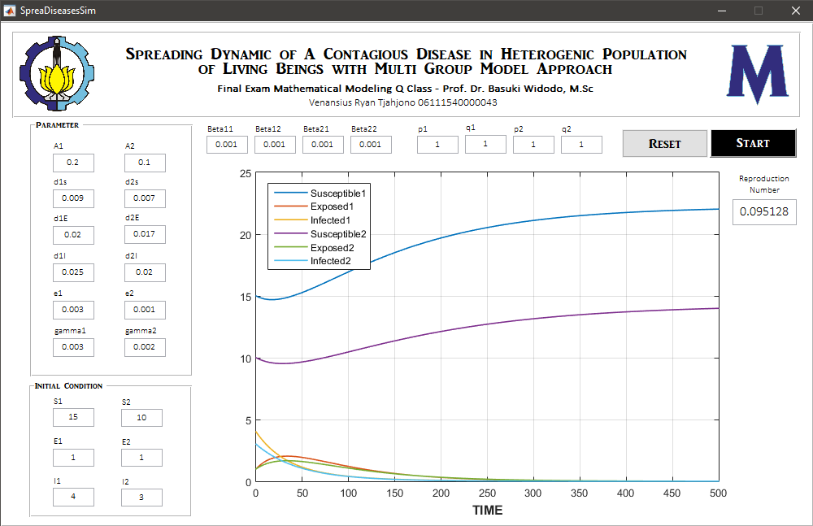

1. **BOTH GROUPS IN ENDEMIC CONDITION**

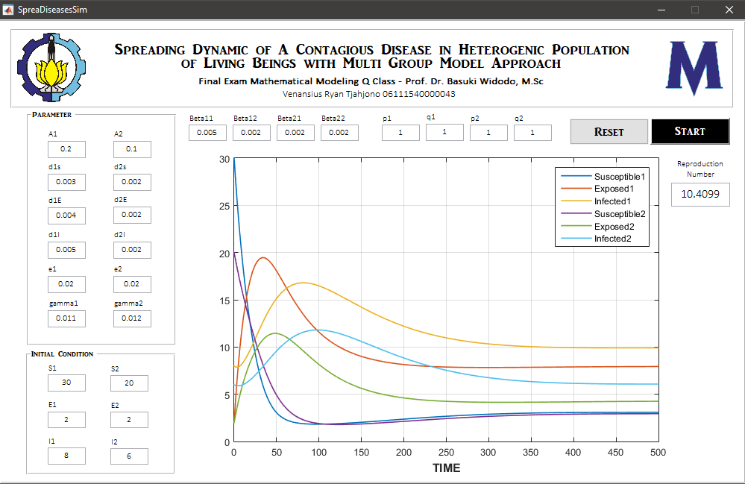

1. **CONDITION WHERE THE FIRST GROUP IS FREE-DISEASE AND THE SECOND GROUP IS ENDEMIC**

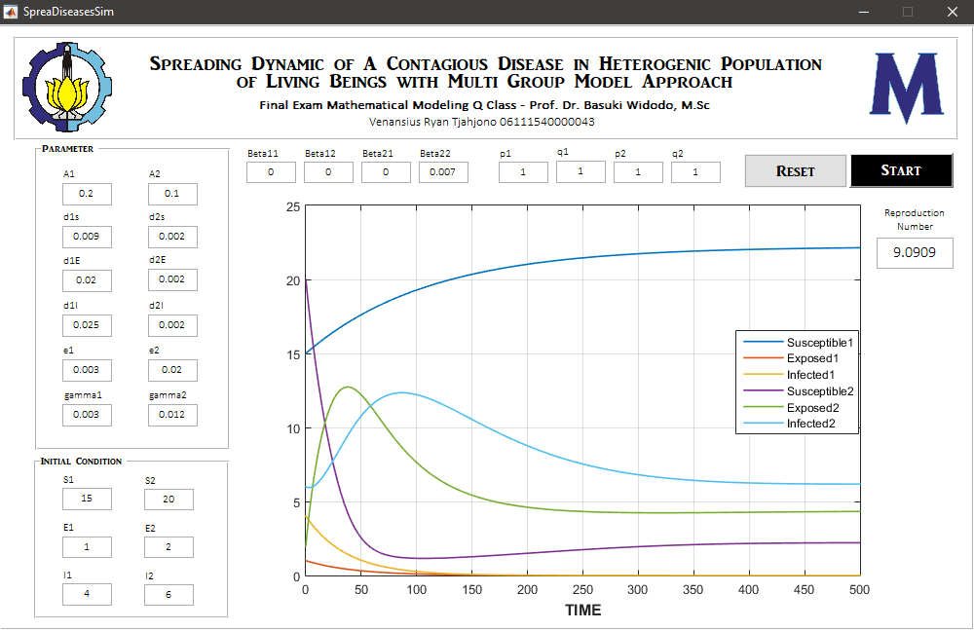

1. **CONDITION WHERE THE FIRST GROUP IS ENDEMIC AND THE SECOND GROUP IS FREE-DISEASE**

